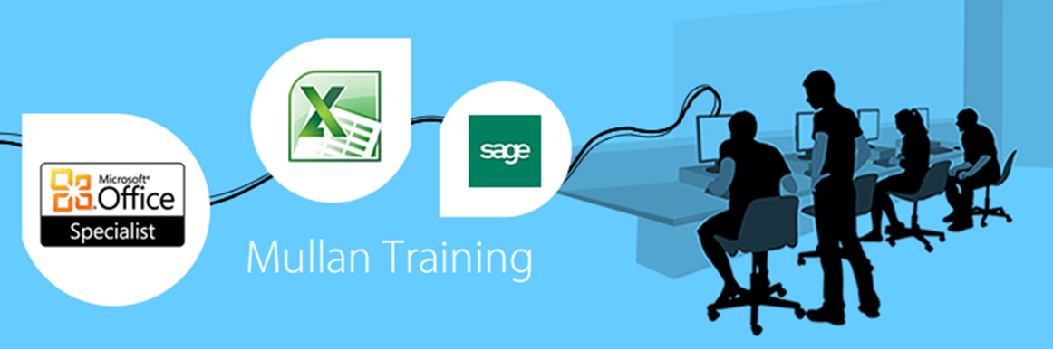

Microsoft Front Page |  | 

PREREQUISITES
- Knowledge of the windows interface would be required. No experience of MS FrontPage is necessary.

BENEFITS
- At the end of this course you will have a good working knowledge of Outlook basics. You will feel more confident using Outlook and be able to manage and communicate using Microsoft Outlook. Users may set up meetings across the network, organise their calendar or delegate it to someone else, manage their to-do list using Tasks, and even leave notes on the desktop. The powerful tools in Outlook in general helps simplify email communication, enhance group planning, scheduling of meetings, and also allow access to the information you need all from one place.

COURSE CONTENT
GENERAL  - Overview Of Sites, Hyperlinks, Browsers, ISP’s  - Load Pages In Web Page Editor And Browser  - Store Pages As HTML And As Web Page Editor Documents  - Print Data And Web Page (HTML) Code  - Use Design Checker (Download Time, Text Frames, Etc)  PUBLISHING TO THE WEB  - Publish Using FrontPage (Changed Pages Only, All Pages)  - Recommend Use Of Alternative FTP Programs & Sites To Download From  - Useful Software - Outline Use Of WinZip & Adobe Reader  VIEWS WITHIN FRONTPAGE EXPLORER – PROVIDE OVERVIEW OF  - Page, Folders, Reports, Navigation, Hyperlinks, Tasks  COMPOSE A NEW PAGE  - Insert & Link With Other Pages  - Naming & Linking Pages – Significance Of Index.Htm Filename  - Page Setup – Header/ Footer, Margins, Title  - Associate With Categories  - Page Transition & Background Sound  - Apply Background Fill/ Images  - Banners  - Add META-Tags  - Set Page Options (Default Font, Thumbnail Size, etc)  - Update Page Details (Date Modified, Author Details, etc) | FORMAT TEXT  - Text properties (Colour, Font, Size, Etc)  - Alignment, Indent,  - Bullets & Numbering  - Styles – Create New, Modify Existing  - Style Sheet Links  GRAPHICS  - Outline Difference Between PNG, GIF & JPEG Files  - Insert & Specify Position  - Copy Images From The WWW And Import Into Site  - Convert Graphic Types  - Set Picture Properties  - Use Of Picture Toolbar (Wrap Text, Rotate, Crop, Set Transparency, Etc)  - Apply Dynamic HTML Animation Effects  - Thumbnails  TABLES  - Use Of Tables Will Be Covered In Detail As Most Of The Structuring Will Be Carried Out Using Them  - Insert/ Delete/ Merge/ Split Cells  - Resize Rows & Columns (With Mouse, Distribute & Autofit)  - Cell Padding, Alignment, Background Picture/ Colour  FRAMES  - Outline Use Of Frames  - Create, Resize, Delete, Split Frames  - Set Frame Properties (Resizable, Scroll Bars)

Microsoft Front Page

COURSE CONTENT
HYPERLINKS  - What Are Links? – ALT Tagging Of Images To Benefit Users  - Relative & Absolute Links  - Link Pages To Create A Web Structure  - Create Links As Standard Text, URL And Graphics  - Break A Single Image Down To Hyperlink To A Number Of Pages ie Create Hotpoints  - Create A Hyperlink To:  - A Web Site Or File On The Internet – Recommend Useful External Sites To Link To (Eg To Instruct Users To Download WinZip, Etc)  - Another Page In Your Web Site  - An Internet E-Mail Address  - An Office File Imported Into The Site  - Display And Verify Hyperlink Status  - Insert/ Format Standard Objects  - Insert Text, WordArt, Clipart, Video Clip, Picture From File (Eg Company Logo)  - Position, Resize Objects  - Align Objects, Send To Front/ Back/ Backward/ Forward  - Format And Animate Objects (Colour, Background Fill, Line Colour)  - Text Styles (Create, Modify And Apply)  - Timestamp  - Table of Contents  - Horizontal Lines  - Borders – Apply to Individual/ All Pages  - Import Files & Folders Into The Web  FORMS  - Create A Form  - Add Fields To The Form  - Set Data Entry Rules  - Collect Information From Form (Send To Filename, Email Address, Database)  - Set Up Confirmation Form  - Create Search Form  - Use Of Database Results Wizard | VARIOUS  - Check In/ Out Files  - Line Breaks  - Tools – Spell Check, Replace, Etc  - Active Elements (Hover Button, Marquee, Etc)  - Create And Use Templates  - Use of Macros  COMPONENTS  - Office spreadsheet/ PivotTable/ chart  - Banner ad manager  - Hit counter  - Hover button  - Marquee  - Include page  - Scheduled picture/ include page  - Search form  - Table of contents

